**Ansible Implementation Plan**

1. Provision four (4) EC2 instances running RHEL: one will serve as the Ansible control node (master) and the remaining three will be configured as managed nodes.
2. Assign clear and meaningful hostnames to each server for easier identification and management. For example: ansible-master for the control node, and ansible-node1, ansible-node2, and ansible-node3 for the managed nodes.
3. To rename a server, use the hostnamectl command. Example:

sudo hostnamectl set-hostname ansible-node1

After setting the hostname, reboot and re-login to verify the new name. You can confirm it using:

hostnamectl

Example output after reboot:

Static hostname: ansible-node1  
Operating System: Red Hat Enterprise Linux 9.6  
Kernel: Linux 5.14.x  
Architecture: x86-64

1. Install Ansible on the Control Node

To set up Ansible on the control node (ansible-master):

[root@ansible-master ~]# yum install ansible-core -y

Once installed, verify the installation:

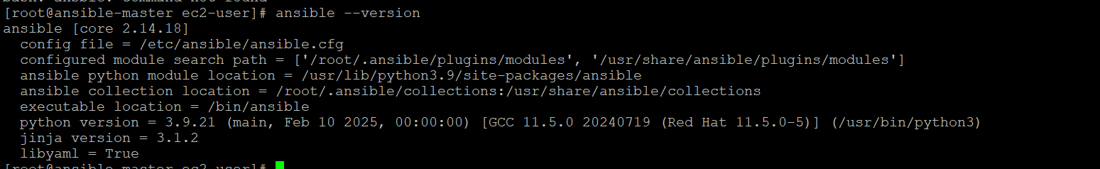

1. Establish the connection between control nodes and manage nodes
2. Try to ssh into control nodes  
   

✅ **Update /etc/hosts**

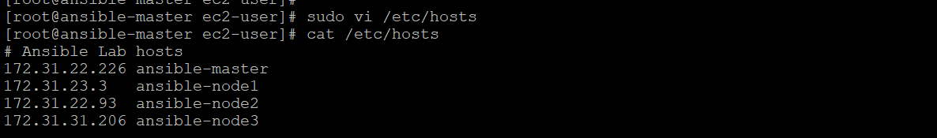

✅ **Steps to set up SSH passwordless authentication**

✅**When prompted** for the file name, just press ENTER to accept the default (~/.ssh/id_rsa).

✅When asked for a passphrase, you can press ENTER to leave it empty for fully passwordless auth.

|  |
| --- |
| [ec2-user@ansible-master ~]$ ssh-keygen -t rsa -b 4096  Generating public/private rsa key pair.  Enter file in which to save the key (/home/ec2-user/.ssh/id_rsa):  Enter passphrase (empty for no passphrase):  Enter same passphrase again:  Your identification has been saved in /home/ec2-user/.ssh/id_rsa  Your public key has been saved in /home/ec2-user/.ssh/id_rsa.pub  The key fingerprint is:  SHA256:FWaZ1rI2ow/Bw3oath2cDhmqdmtxFeGrhxn3Lc9SHg0 ec2-user@ansible-master  The key's randomart image is:  +---[RSA 4096]----+  | ..++ |  | ..o=.. |  | o.o.o |  | . *o= E |  | ..*S* o o |  | o B*B. .o . |  | . ++O.+oo.. |  | o o o.o o+. |  | . o.. .o |  +----[SHA256]-----+  [ec2-user@ansible-master ~]$ cat ~/.ssh/id_rsa.pu  cat: /home/ec2-user/.ssh/id_rsa.pu: No such file or directory  [ec2-user@ansible-master ~]$ cat ~/.ssh/id_rsa.pub  ssh-rsa  ec2-user@ansible-master  [ec2-user@ansible-master ~]$ ssh ec2-user@ansible-node1  The authenticity of host 'ansible-node1 (172.31.23.3)' can't be established.  ED25519 key fingerprint is SHA256:YSOlfbTz1HBZU3k3RAJthtu/cvfiFMRU+3al+/350y4.  This key is not known by any other names  Are you sure you want to continue connecting (yes/no/[fingerprint])? yes  Warning: Permanently added 'ansible-node1' (ED25519) to the list of known hosts.  Register this system with Red Hat Insights: rhc connect  Example:  # rhc connect --activation-key <key> --organization <org>  The rhc client and Red Hat Insights will enable analytics and additional  management capabilities on your system.  View your connected systems at https://console.redhat.com/insights  You can learn more about how to register your system  using rhc at https://red.ht/registration  Last login: Sun Jul 20 10:58:33 2025 from 103.191.100.200  [ec2-user@ansible-node1 ~]$ |